**HAPPY MEAL**

**Design Document**

**Version 1.0**



**Group Id:** xxxxxx

**Supervisor Name:** Maham Murtaza Khan

**Revision History**

|  |  |  |  |
| --- | --- | --- | --- |
| **Date (dd/mm/yyyy)** | **Version** | **Description** | **Tested By** |
| **9/01/24** | **1.0** |  | bc200405761  Eman Batool |
|  |  |  |  |
|  |  |  |  |
|  |  |  |  |

**Table of Contents**

1. Introduction of Design Document
2. Entity Relationship Diagram (ERD)
3. Sequence Diagrams
4. Architecture Design Diagram
5. Class Diagram
6. Database Design
7. Interface Design
8. Test Cases

1. Introduction of Design Document

The Design Document maps the requirements into architecture-independent of how these requirements will be accomplished. The architecture defines the components, their interfaces, and behaviors. In the Design Phase, we transform the requirements gathered during the Analysis Phase into a Design Document that accurately describes the design of the system.

The purpose of the Design Phase is to transform the requirements into complete and detailed system design specifications once the design is approved the Design Document will serve as input to the Development Phase. Tools and techniques used in this phase are listed below:

* ER Diagram
* Sequence Diagram
* Architecture Design Diagram
* Class Diagram
* Database Design
* Interface Design
* Test Cases

1. Entity Relationship Diagram (ERD)

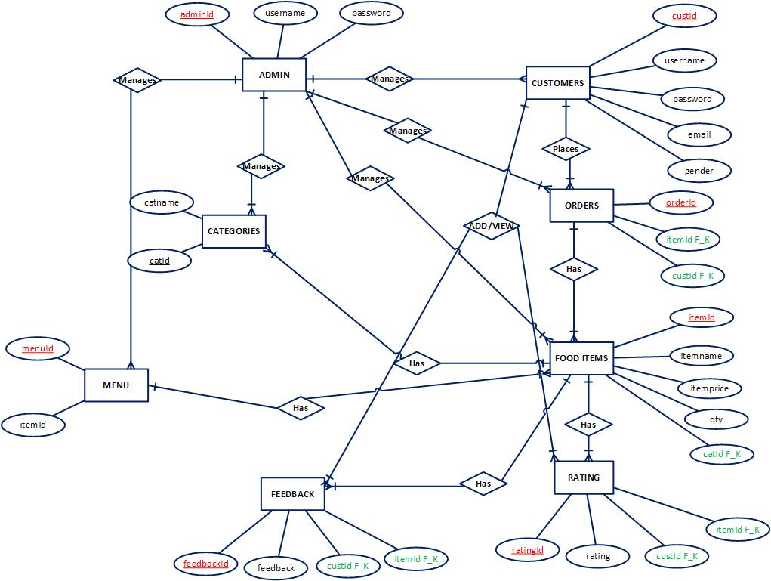

1. Sequence Diagrams

Registration:

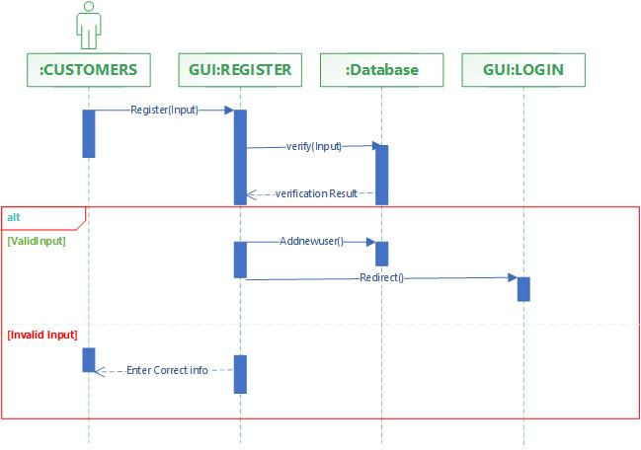

Login Panel:

Add Categories:

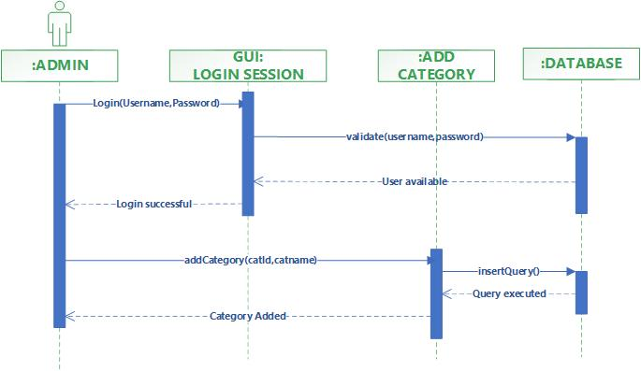

Manage Categories

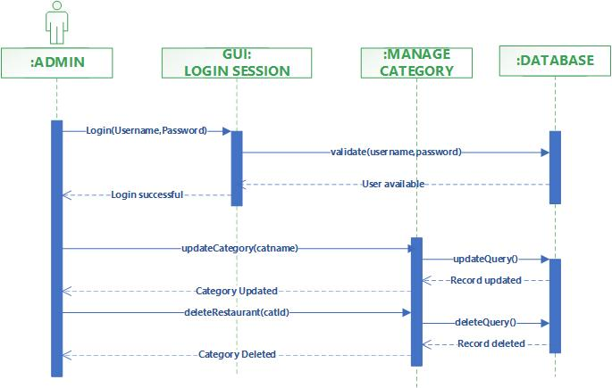

Add Feedback

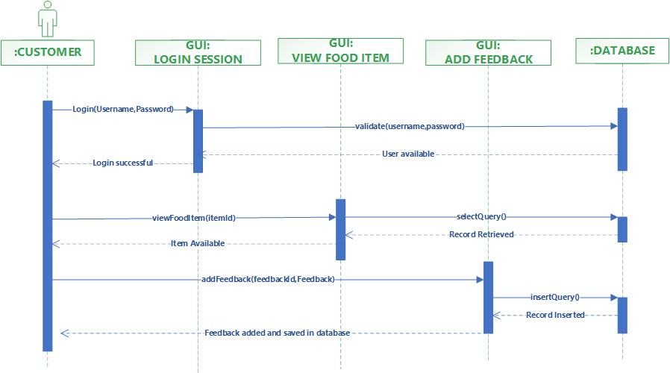

Add Food Item

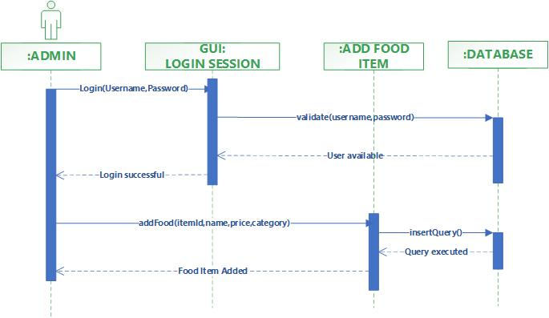

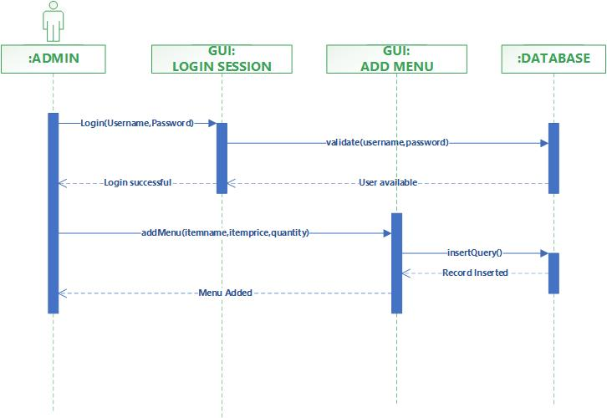Add Menu:-

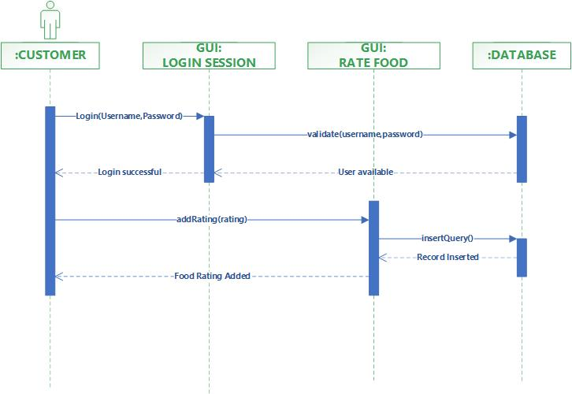Rate Food Item:-

Manage Food Item:

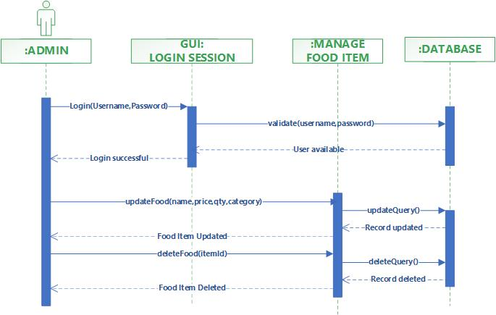

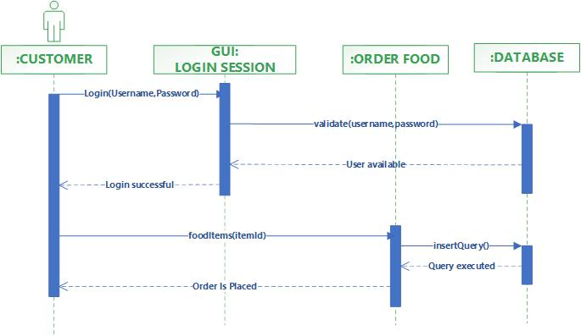Place Order:-

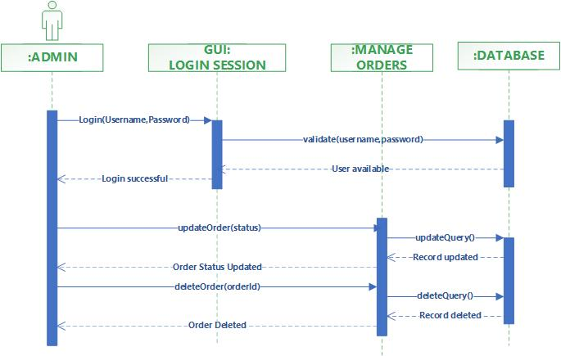Manage Orders:-

Browse Food Items:-

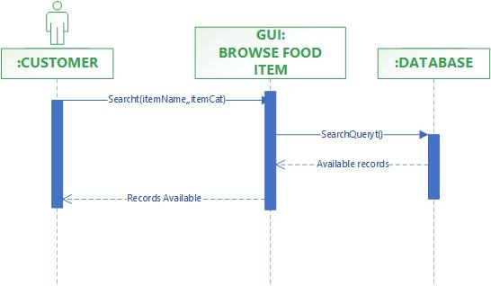

View Feedback:-

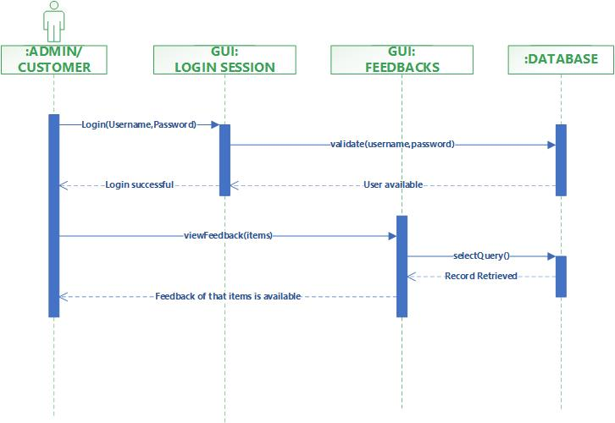

View Order:-

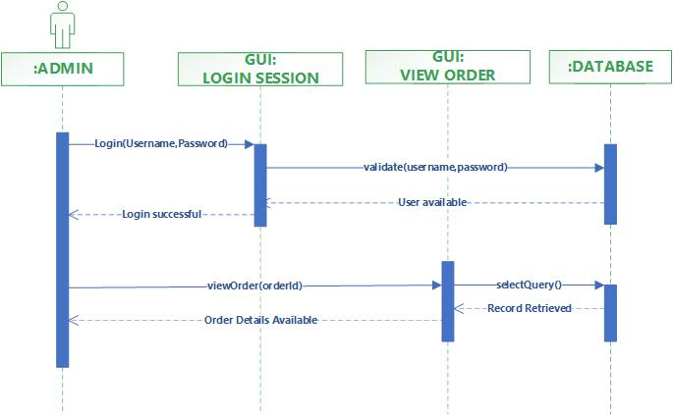

View Rating:-

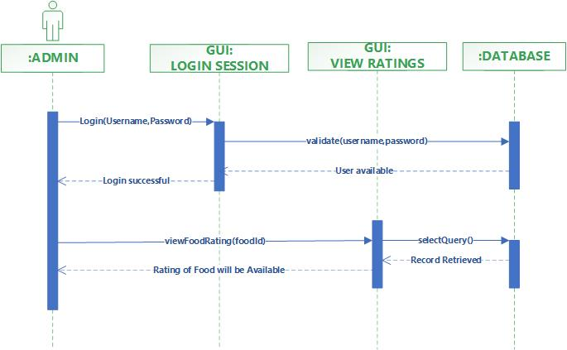

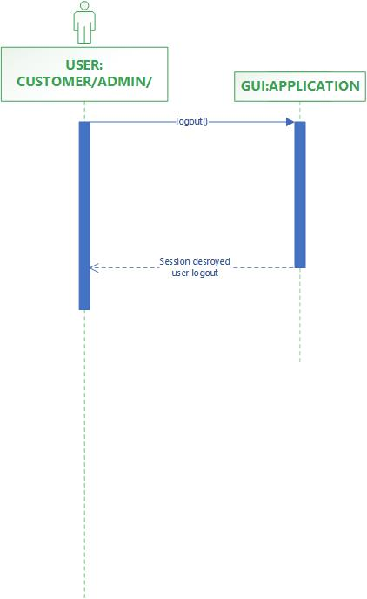Logout:-

1. 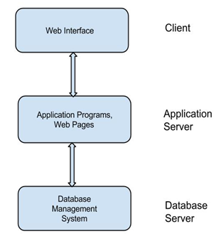Architecture Design Diagram
2. Class Diagram

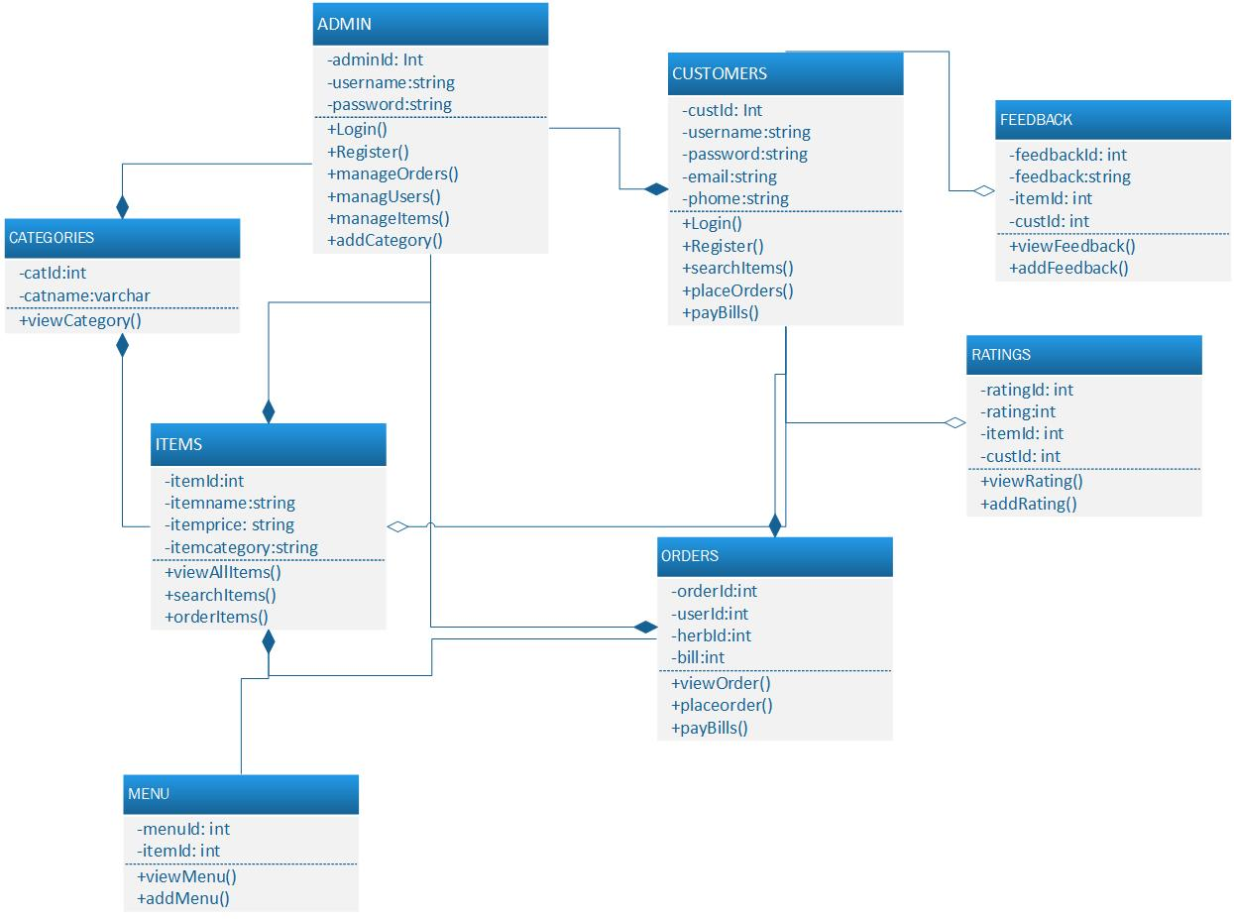

1. Database Design

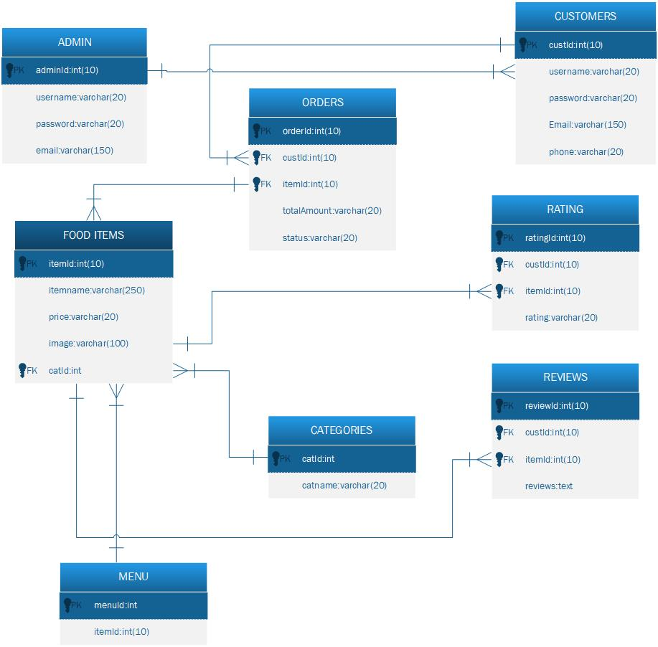

1. Interface Design
2. Test Cases

**REGISTER:**

|  |  |
| --- | --- |
| Pre-condition | Application interface must be available. |
| Action | 1. Open application interface of create account 2. Fill the form of registration 3. Click on “Register” button to get registered |
| Expected Results | Customers/Gas Station successfully created in database. |
| Results | Pass |
| Tested By | BC190402933 (Sughra Bibi) |

|  |  |
| --- | --- |
| Pre-condition | Application interface must be available. |
| Action | 1. Open application interface of create account 2. Fill the form of registration 3. Click on “Register” button to get registered |
| Expected Results | User successfully created in database. |
| Results | Customer, |
| Checked By | Bc200405761 (Eman Batool) |

**LOGIN:**

|  |  |
| --- | --- |
| Pre-condition | User must be created first , Application interface must be available |
| Action | 1. Open application interface of login 2. Enter user name and password 3. Click on “Login” button |
| Expected Results | User successfully login and able to further work |
| Results | Customer, Admin |
| Checked By | Bc200405761 (Eman Batool) |

**BROWSE MENU:**

|  |  |
| --- | --- |
| Pre-condition | User must be registered and Application interface must be available |
| Action | 1. Open application interface and fill the criteria of browse menu items. 2. Click on the “View Menus” button |
| Expected Results | All items that fall on the search criteria will be displayed on the website |
| Results | Customers |
| Checked By | Bc200405761 (Eman Batool) |

**PLACE ORDER**

|  |  |
| --- | --- |
| Pre-condition | The application interface must be available. The customer must be Logged in |
| Action | 1. Open application interface. 2. Select the desired items. 3. Click on the place order button. |
| Expected Results | Order will be placed. |
| Results | Customers |
| Checked By | Bc200405761 (Eman Batool) |

**TRACK ORDER**

|  |  |
| --- | --- |
| Use Case id | **5** |
| Pre-condition | The application interface must be available. The customer must be Logged in |
| Action | 1. Open application interface. 2. Select the view my orders tab. 3. All orders placed by you will be available. |
| Expected Results | Order details will be available to customer. |
| Results | Customers |
| Checked By | Bc200405761 (Eman Batool) |

**ADD RATING:**

|  |  |
| --- | --- |
| Pre-condition | The customer must be registered and logged in to the system. |
| Action | 1. Open application interface and login by providing valid username and password 2. Select desired food item 3. Add your rating using stars 4. Click on the add rating button of desired Food item |
| Expected Results | Rating of particular food item has been added to the system. |
| Results | Customers |
| Checked By | Bc200405761 (Eman Batool) |

**MANAGE CUSTOMERS**

|  |  |
| --- | --- |
| Pre-condition | * 1. Admin users must be logged in.   2. The database should be available on the computer. |
| Action | 1. Open application interface. 2. Click on manage customers tab. 3. Click on desired function(Add, Edit/ Delete Customers) |
| Expected Results | Customers will be updated in database and updated details will be available on website as well |
| Results | Admin |
| Checked By | Bc200405761 (Eman Batool) |

**MANAGE CATEGORY**

|  |  |
| --- | --- |
| Pre-condition | 1. Admin users must be logged in. 2. The database should be available on the computer. |
| Action | 1. Open application interface. 2. Click on manage items tab. 3. Click on desired function(Add, Edit/ Delete Categories) |
| Expected Results | Categories will be updated in database and updated details will be available on website as well |
| Results | Admin |
| Checked By | Bc200405761 (Eman Batool) |

**MANAGE FOOD ITEMS**

|  |  |
| --- | --- |
| Pre-condition | * 1. Admin users must be logged in.   2. The database should be available on the computer. |
| Action | 1. Open application interface. 2. Click on manage items tab. 3. Click on desired function(Add, Edit/ Delete Item) |
| Expected Results | Items will be updated in database and updated details will be available on website as well |
| Results | Admin |
| Checked By | Bc200405761 (Eman Batool) |

**MANAGE ORDER**

|  |  |
| --- | --- |
| Pre-condition | * 1. Admin users must be logged in.   2. The database should be available on the computer. |
| Action | 1. Open application interface. 2. Click on manage order tab. 3. Click on desired function (Add, Edit/ Delete Order) |
| Expected Results | Items will be updated in database and updated details will be available on website as well |
| Results | Admin |
| Checked By | Bc200405761 (Eman Batool) |

**VIEW FEEDBACK**

|  |  |
| --- | --- |
| Pre-condition | 1. Admin users must be logged in 2. Database should be available on the computer. |
| Action | 1. Open application interface. 2. Click on view feedback Button |
| Expected Results | Details of feedback Added by customers is available. |
| Results | Admin |
| Checked By | Bc200405761 (Eman Batool) |

**LOGOUT**

|  |  |
| --- | --- |
| Pre-condition | The application interface must be available and any of the actor must be Logged in. |
| Action | 1. Open application interface. 2. Click on Logout Button. |
| Expected Results | Session is destroyed and actor will be logout from system. |
| Results | Admin,Customer |
| Checked By | Bc200405761 (Eman Batool) |